Seven Segment Display
CP024
Image:
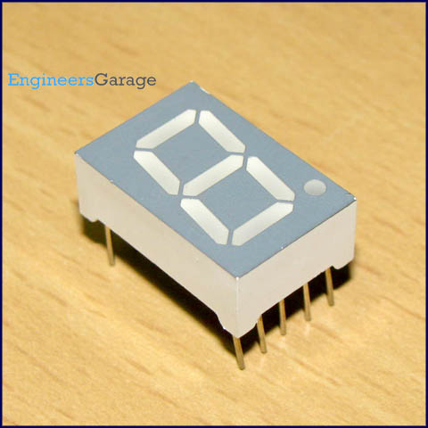
A seven segment display is the most basic electronic display device that can display digits from 0-9. They find wide application in devices that display numeric information like digital clocks, radio, microwave ovens, electronic meters etc. The most common configuration has an array of eight LEDs arranged in a special pattern to display these digits. They are laid out as a squared-off figure ‘8’. Every LED is assigned a name from 'a' to 'h' and is identified by its name. Seven LEDs 'a' to 'g' are used to display the numerals while eighth LED 'h' is used to display the dot/decimal.

A seven segment is generally available in ten pin package. While eight pins correspond to the eight LEDs, the remaining two pins (at middle) are common and internally shorted. These segments come in two configurations, namely, Common cathode (CC) and Common anode (CA). In CC configuration, the negative terminals of all LEDs are connected to the common pins. The common is connected to ground and a particular LED glows when its corresponding pin is given high. In CA arrangement, the common pin is given a high logic and the LED pins are given low to display a number. Find out more information about a seven segment display and its working.

Pin Diagram:
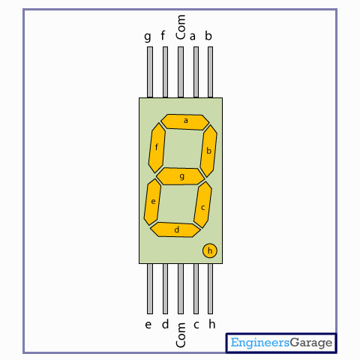

Insight - How Seven Segment Display works

Table of Contents:
- Insight - How Seven Segment Display works
- Top & Bottom View
- Internal Structure and Circuit
- Display
In 1910 Frank W. Wood made a board which can display number and after several modifications, today it’s called 7-segment display. 7 segment display is a 10 pin electronic component with eight led’s embedded inside it to displays number from 0 to 9.It is available in two configurations: common cathode and common anode. All the 8 LED terminals have their one end internally shorted and linked with the middle pins such that it serves as a common terminal (cathode or anode). Middle pin of both sides are shorted with each other which serves as a common terminal. 7 led are used to form the digits while the 8thone is for the dot which helps in identifying the correct orientation.

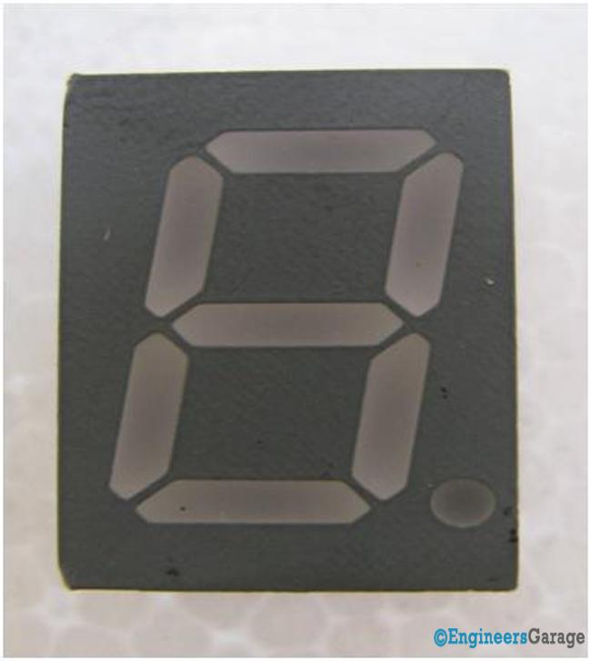
Fig. 1
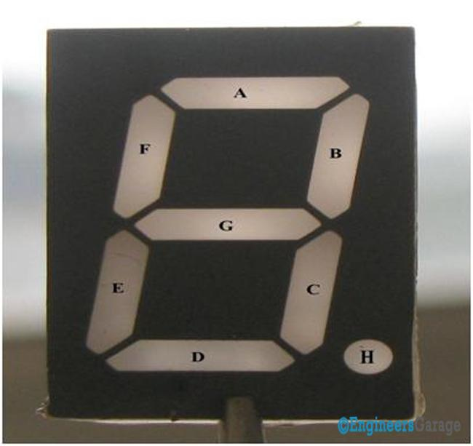
Fig 2
From the top view we can see the7-segment is divided into 8 fragments and is marked in a sequential manner. Let’s say we want to display 1 then B and C fragments will glow for 2 A, B, D, E, F will glow. The remaining numbers are displayed in the same manner. Though it is called as seven segments, it has eight LEDs. The seven LEDs are used to display the numbers & characters and the eighth one is used for glowing the dot. Pictorial description is shown above in Fig.2.
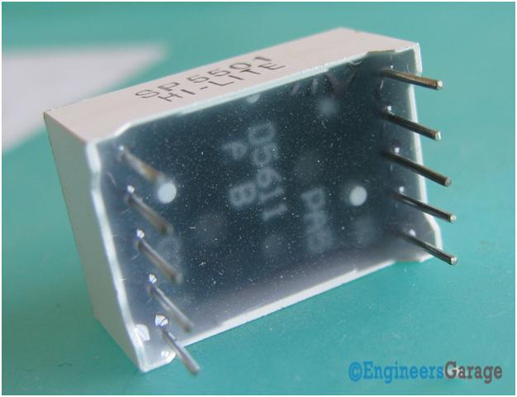
Figure 3
Bottom image of 7 segment display is shown in the Figure 3.
BREAKING IN:
It is very hard to break this type of small component because of size and tight packaging. We broke the component in two parts i.e. display and the circuit segment. Both parts are surrounded by an insulating material made of ceramic, glass and plastics which helps the display and the circuit segment to remain intact. The device is packed using glue like thing which solidifies on cooling and then coated with desired substance to give attractive looks.

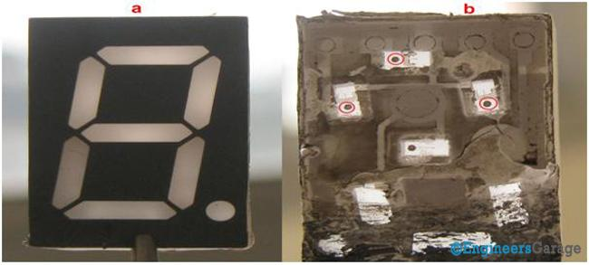
Fig 4a Fig 4b

Fig 4.a shows the front of the display which is same as described in the introduction.
On flipping the front part the fig 3b shows the inner view of the display. The small dots encircled in fig 4b are the semiconductor or LED wafer with a small wire attached to them called whisker. This image also shows that how the insulating material surrounds the inner view of display.
HOW IT WORKS:
At Engineers Garage, we are more curious to know how this stuff works instead of what this stuff do. So let’s start with it.
Circuit
After breaking in the actual pin diagram was visible which shows us how the LED’s are placed and their interconnections which helps in displaying digits. The internal shorting of the common pins on both sides is shownby blue line in Fig 5.

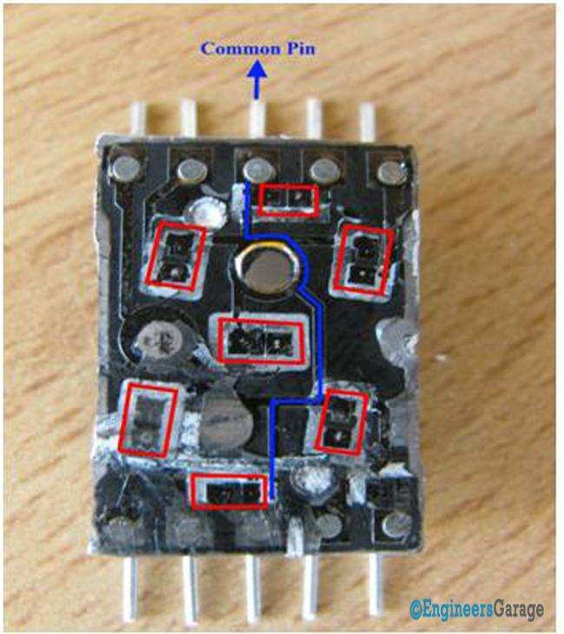
Fig5.
The LED terminal gets the voltage supply from the remaining pins. The Red rectangular boxes in Fig 4 show various LED terminals. When voltage is given to a pin then its respective LED terminal gets the power and the LED glows. The circuit is designed in such a way that voltage at various pins can be applied at a same time.
Display:
The display unit is divided into various fragments. These fragments comprises of small plastic particle with LED in housed into them as shown in Fig. 6

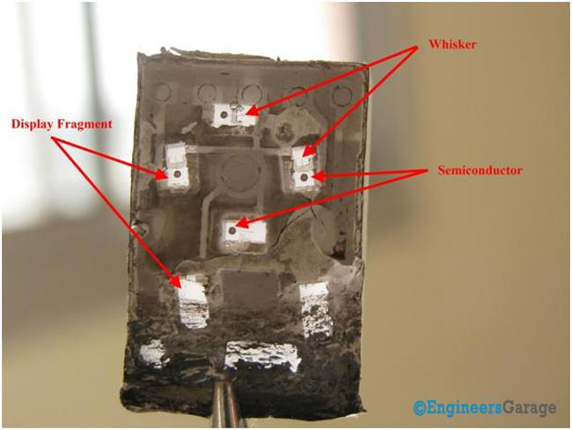
Fig. 6
A semiconductor or LED wafer is a PN junction Diode which emits light when the electrons combine in the active region.
Whisker is a wire as thin as hair.When the back side is placed onto the circuit whisker gets linked with the LED terminal. When the supply is given to the terminals the connection of the LED gets completed and it displays the digit.

